Week 4s task: Binary Search
After gathering the Json data and using the merge sort algorithm to sort the lastEntranceInEngineRoom information. I started the implementation of Binary Search to find lastEntranceInEngineRoom times between 2 ranges. I choose the Input field way. I created two textmeshpro input fields (object) named lowinputvalue and highinputvalue. Before using these two values, I added a failsafe of course. Making any wrongdoing in the input field results in the execution not following through, rendering a message and letting you retry again. During the Binary Search I only used years as search implementation.
Weeks 5s Task: Binary Tree
Here I used DFS, depth-first search for both creation of the tree and the search. The difference in this task I added separate input fields for Year, Month, Day and hours. Before creation, I used a sorted array for this binary tree. The searching in this tree was similar to the binary search I had previously, this time I used all the input Year, Month, Day and hours. Funny thing here I parsed the lastentranceinengineroom string to an int, rather than using DateTime, which could be a better choice. Here is a picture of how it looks like. 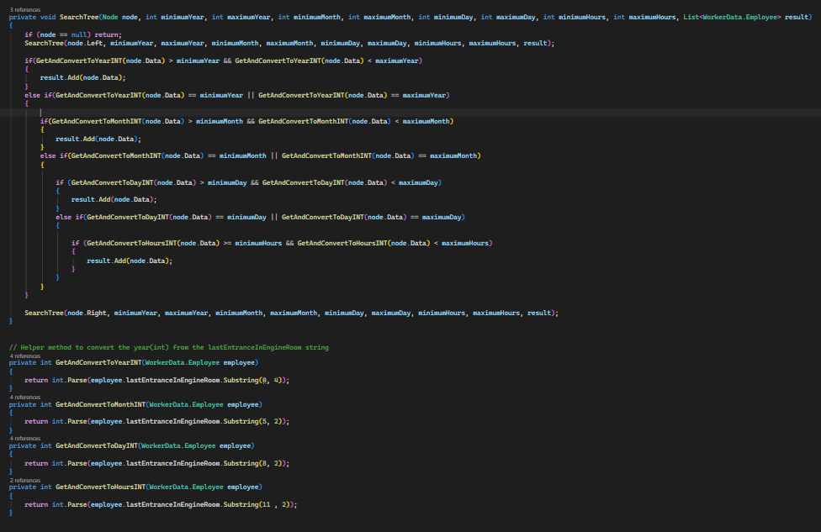
As you can see the conditions are tailored for this specific case. It saves dates if we use broader yearly dates. Otherwise, it checks for specific condition when the nodes year value and the lowinput/highinput is the same. Just then it goes deeper. When I get the result of everything I just do a foreach loop where I print both entrance and exit:
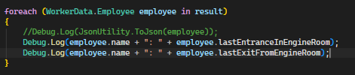
These were my suspects:
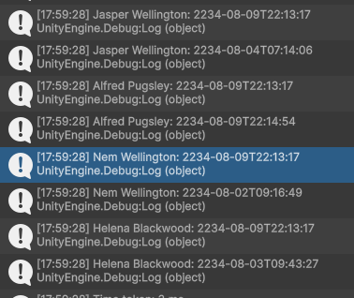
We can clearly see that Alfred Pugsley matches the description.

Challenges during the course:
2 words, many challenges. I’m quite new to the programming part of things, and this course was hard in my opinion. First week, stacks and queues, I have never heard of those structures before. Putting them to code made it even harder for me. I am at point where I want to learn how to code from pseudo code. Knowing these algorithms are invented by great mathematicians, I feel stressed doing the code from no reference at all. To solve this problem, I feel the need to look up source code. And then I learn better if I can let someone tell me each line of code 1 by 1. This is perfect case to use AI, here I let Claude create a click next visual representation: 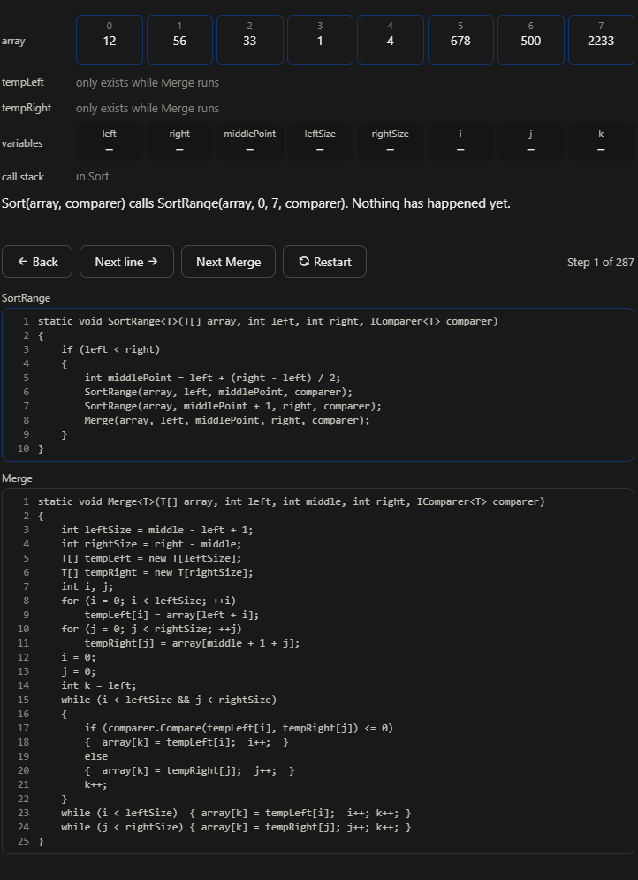
Notice the buttons, here I can go line by line and it explains what’s happening. Recursion was extremely weird for me. I could never figure out that you can call the same method and fill a call stack. Intuitively it feels like something would crash if you called the same method in the method. To be honest I felt stuck for the majority of time. I created this helper program to understand Stacks and queues, mergesort and binary tree line by line. Binary search was kind of similar with how mergesort worked with the separating, halving the array until only on index is remaining. Rendering the answer.

